Product design and documentation

**Data Explorer Screen**

**SDV602 Software Development 2**

**Tan Yi Xiong (aka Ian)**

Contents

Table of Contents:

Introduction: 3

The Purpose: 3

Data Source: 3

Summary: 3

Application Screens & Storyboards: 4

1. Login 4

2. Register 4

3. Home 6

4. Data Explorer 6

Program Flowchart: 8

Reference: 9

Tools Used: 9

# Introduction:

A communication platform for analysts in the Monitoring Trends in Burn Severity (MTBS) project is desperately needed. This platform will allow analysts from different parts of the country to come together to analyse data and make critical decisions in order to allow for better preparations and precautions.

# The Purpose:

The purpose of this project is to build the communication platform for the analysts. In order to meet their needs, there are some requirements. Here are some listed below:

* To provide live and interactive charts
* To be able to explore data from a data source
* Able to display information that relate to the information displayed
* Provides brief summary of data fields
* Able to display at least 3 different DESs
* A remote API
  + Login and logout
  + A chat service
* A database
  + store the data source
  + Chat history
  + User information
* The entry point will be from the analyst’s command line interface (CLI).

## Data Source:

All the csv files that can be processed are in the source below.

<https://hub.arcgis.com/datasets/usfs::2015-fire-occurrence-locations-1/about>

### Summary:

Monitoring Trends in Burn Severity Fire Occurrences and Burned Area Boundaries

A map service depicting Fire Occurrence Locations and Burned Area Boundaries from 1984 through 2018. The Monitoring Trends in Burn Severity (MTBS) project maps the location, extent, and severity of all large fires in the conterminous United States (CONUS), Alaska, Hawaii and Puerto Rico from 1984 to present. All documented fires greater than 1,000 acres in the western U.S. and greater than 500 acres in the eastern U.S. are mapped across all ownerships. The project produces geospatial and tabular data for analysis at a range of spatial, temporal, and thematic scales and are intended to meet a variety of information needs that require consistent data about fire effects through space and time. MTBS is conducted through a partnership between the U.S. Geological Survey National Center for Earth Resources Observation and Science (EROS) and the USDA Forest Service Remote Sensing Applications Center (RSAC).

## Application Screens & Storyboards:

The DES consist of 4 screens:

## Login

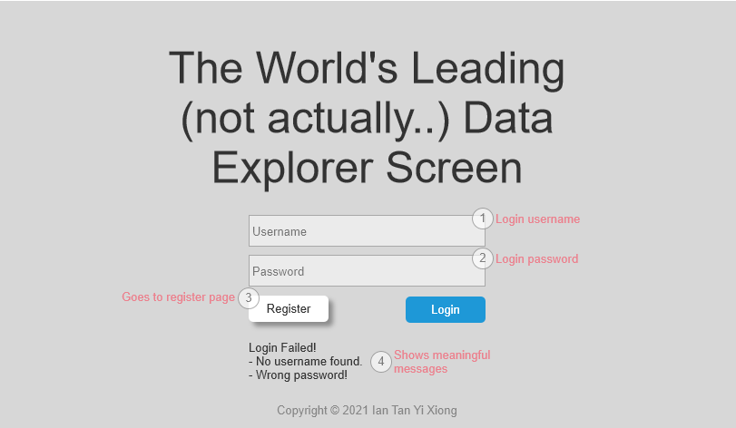

As shown above, this is truly the World’s Leading Data Explorer Screen.. Analysts are able to login here, or choose to register a new account. If there’s any issues with the username or password, users will be able to see displayed messages in (4).

## Register

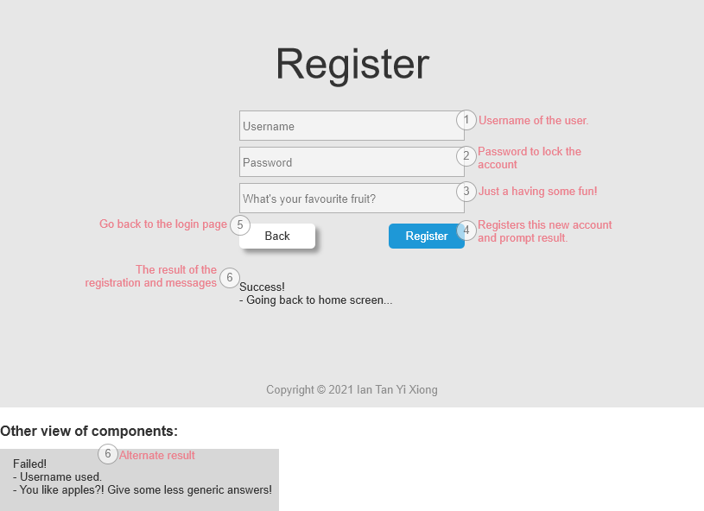

New users register their new accounts here. The required fields are the username, password and … their favourite fruit. The final question is so that analysts can break-the-ice when it’s their first time meeting each other in the DES.

As you can see, not always things go the way you want. For example in the second section of the storyboard you see above, a username was already taken. Or, the user didn’t bother to answer the last question sincerely and entered a generic answer like “Apples”. This is truly unacceptable. Therefore, we will have a message to prompt the user to provide a different username and especially, a different fruit.

## Home

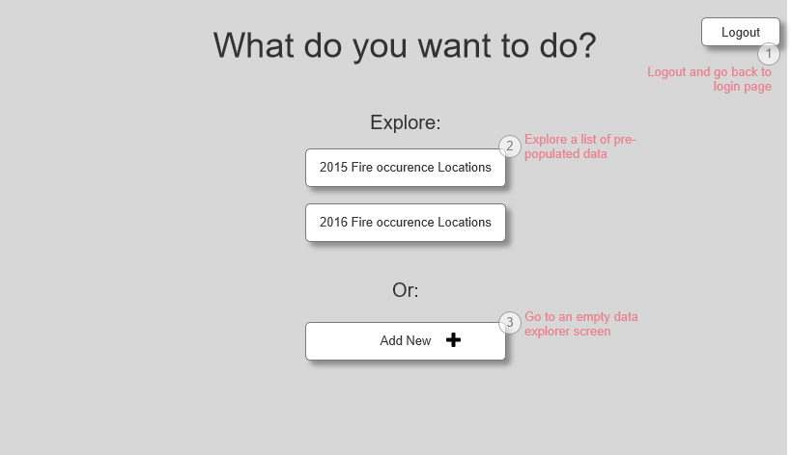

The home page is main page for navigating around different Data Explorers. The user can also open up a blank Data Explorer and then upload a different dataset. There are a **maximum of 3** data explorers that can be opened and viewed. And when one a data explorer is updated, other users will also be able to see it.

## Data Explorer

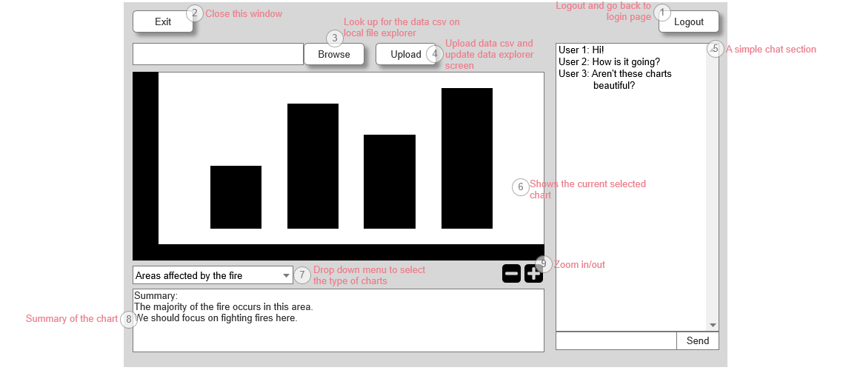

The home page is where the magic happens. As we can see from the here, there’s a delightful browse button (3) that allows the analyst to browse their local file directory to select the file they want to upload. After they do that, they can without doubt click the Upload button (4) to upload the csv file to be processed by the application.

(6) is the placeholder for the majestic charts. They will be populated after the csv file is processed.

(5) is a chat section that allows login users to mingle and talk about “fire”.

(8) Summary is just to display information about the data processed.

(7) is a drop down menu. Toggling this would change the view of the data explorer. While the map is the main attraction, we have other graphs that are also interesting as well. Here are some of the analytics for the dataset:

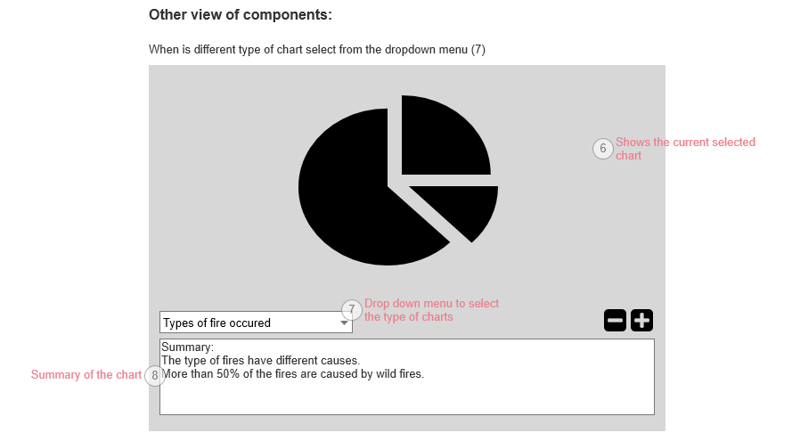

Here’s another one:

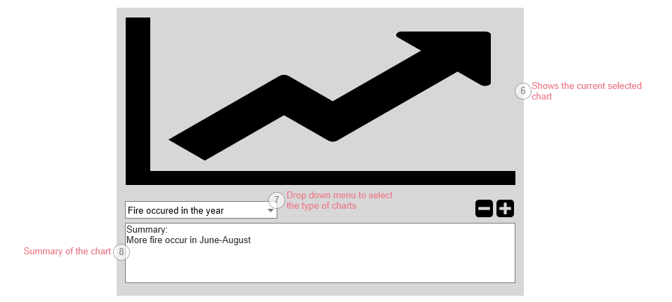

## Program Flowchart:

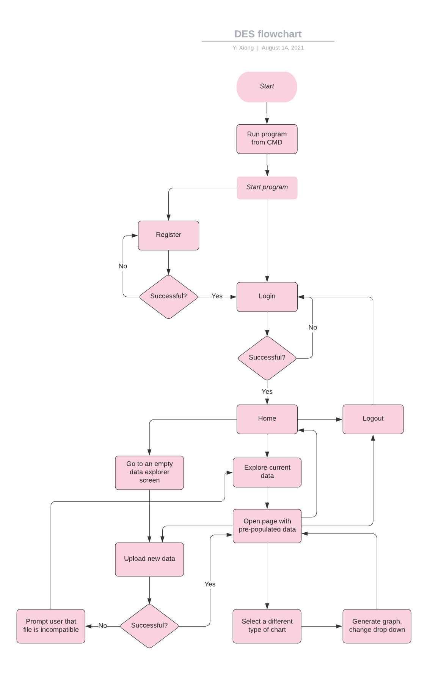

# Reference:

<https://www.sciencebase.gov/catalog/item/5e541969e4b0ff554f753113>

# Tools Used:

Axure - <https://www.axure.com/>

Lucidchart - <https://lucid.co/>